**PowerMILL Excel SetupSheet**

This plugin is meant for users wanting to export their setupsheets to excel instead of HTML. A template will need to be created in Excel which, at the time of processing, will be opened by the plugin and filled with the current project data. There are different type of setupsheets supported:

1-Simple tool list

That tool list can have the format you want. The most important detail is that the worksheet must be called **ToolList.** Once the plugin finds a parameter that is linked to the tool, it will copy the entire row down for each tool and replace the parameters with the real tool values. In that sheet, only parameters starting with {tool. or {project. or {ncprogram. can be used. The template called Tool_List.xlsx installed with the plugin will give you the following result and can be used as a starting point for your customized tool list.

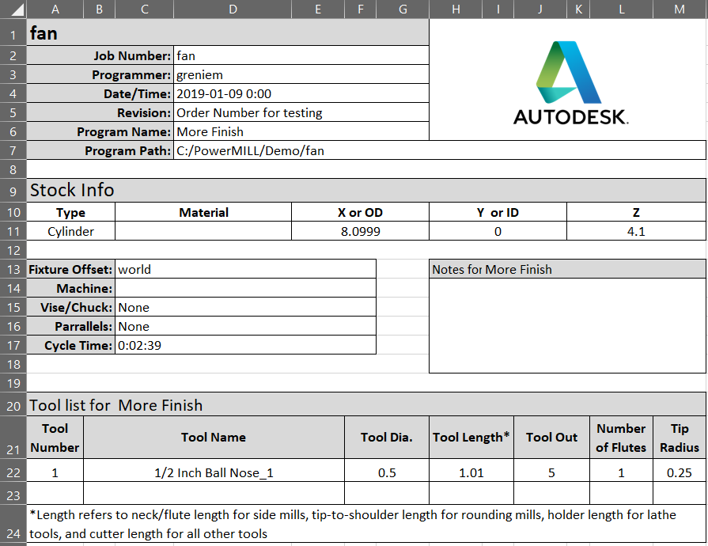

2-Simple toolpath list

That toolpath list can have the format you want exactly like the tool list. The most important detail is that the worksheet must be called **NCProg_Summary**. Once the plugin finds a parameter that is linked to a toolpath, it will copy the entire row down for each toolpath. Only parameters starting with {toolpath. or {project. or {ncprogram. can be used. The template called Toolpath_List.xlsx installed with the plugin gives you the following result and can be used as a starting point for your own list.

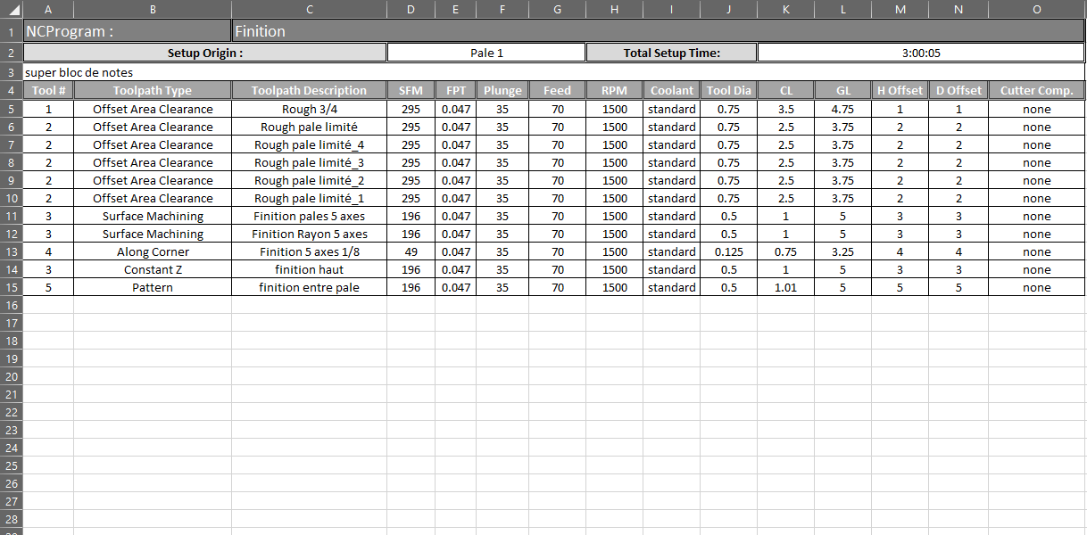

3-Advanced toolpath list

That toolpath list format is similar to the existing HTML format we already have in PowerMILL. It will generate a worksheet for each ncprogram and each toolpath independently to get more detail. Links between worksheet can be automatically added to make browsing easier between all the different tabs.

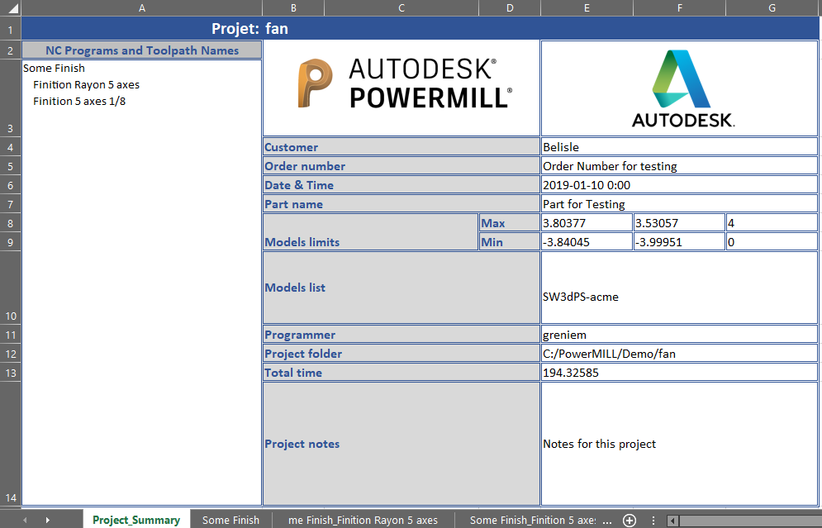

How it works:

1-Template must be build with the usage of the parameters you’ll find in this document. Refer to the 3 templates available in the install folder to better understand.

2-Within the plugin options, make sure you select the template you would like to use. That template will be saved on your computer so that you don’t have to reload it for every project.

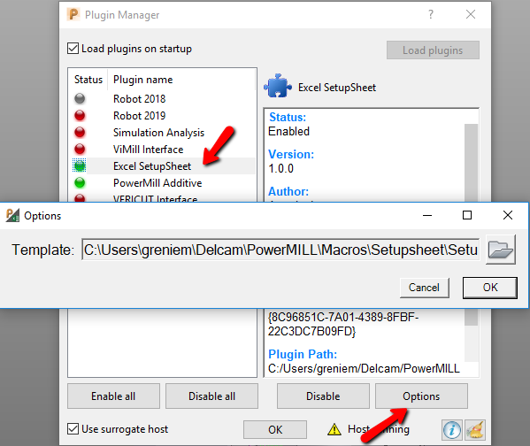

3-In the plugin form, the left list represent the available NC Programs while the right list the ones to export. All NC Programs from the right list will be exported and merged inside the same setupsheet so if you need different Excel file for each of NC Programs, you’ll need to run it several times.

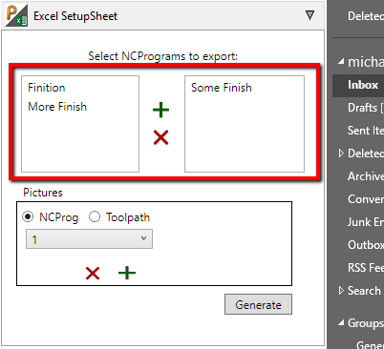

4-The picture section allows you to grab snapshots to be integrated to your setupsheet. By selecting NCProg, you’ll have a pull down menu that will allow you to save up to 5 pictures for each nc program. Make sure you select the nc program you want the picture to be saved for from the right list, select what picture you need to modify from the pulldown, position you view as desired and hit the green plus sign. Once the snapshot taken, you should see a preview of the picture in the plugin. You can always remove it or change it. Those pictures will be saved within the project folder along with the setupsheet Excel document. The same procedure applies for toolpath specific pictures except you can only get one for each toolpath. When the toolpath radio button is selected, the pulldown menu will show a list of the available toolpaths to save pictures for.

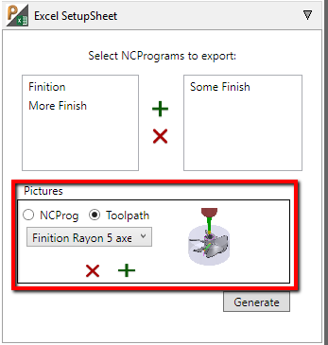

**Parameters list**

Project Parameters

|  |  |
| --- | --- |
| Parameter name | Description |
| {project.path} | Project Path |
| {project.name} | Project Name |
| {project.ordernumber} | Order Number from the information page |
| {project.programmer} | Programmer from the information page |
| {project.partname} | Part Name from the information page |
| {project.customer} | Customer from the information page |
| {project.date} | Today’s date |
| {project.notes} | Notes from the information page |
| {project.totaltime} | Total estimation time of all NC Programs selected |
| {project.machmodels.maxx} | All machinable models maximum X value |
| {project.machmodels.maxy} | All machinable models maximum Y value |
| {project.machmodels.maxz} | All machinable models maximum Z value |
| {project.machmodels.minx} | All machinable models minimum X value |
| {project.machmodels.miny} | All machinable models minimum Y value |
| {project.machmodels.minz} | All machinable models minimum Z value |
| {project.modelslist} | List of all the models in the project. Each models to be outputted in the same cell on different lines. |
| {project.combinedlist} | List of all the NC Program with their Toolpaths and hyperlink to the appropriate worksheet IF the Toolpath_Details worksheet is found in the template. See Toolpath_List-Complete.xlsx for a sample. |
| {project.backtoprojectsummaryfull} | Hyperlink to jump to the Project_Summary_Full tab |
| {project.picture1} | Snapshot #1 for the current project |
| {project.picture2} | Snapshot #2 for the current project |
| {project.picture3} | Snapshot #3 for the current project |
| {project.picture4} | Snapshot #4 for the current project |
| {project.picture5} | Snapshot #5 for the current project |

NC Programs Parameters

|  |  |
| --- | --- |
| Parameter name | Description |
| {ncprogram.name} | Name of the NC Program |
| {ncprogram.outputworkplane} | Output workplane from the current NC Program |
| {ncprogram.totaltime} | Total cutting time for the current NC Program |
| {ncprogram.cuttinglength} | Total cutting length for the current NC Program |
| {ncprogram.notes} | Notes for the current NC Program |
| {ncprogram.filename} | NC Code output file name |
| {ncprogram.optionfile.name} | Post processor name |
| {ncprogram.optionfile.fullname} | Post processor name with path |
| {ncprogram.backtoprojectsummary} | Hyperlink to go back to the Project_Summary page. |
| {ncprogram.block.type} | Type of the first toolpath stock |
| {ncprogram.block.xsize} | X dimension of the first toolpath stock |
| {ncprogram.block.ysize} | Y dimension of the first toolpath stock |
| {ncprogram.block.zsize} | Z dimension of the first toolpath stock |
| {ncprogram.toolpaths} | List of toolpaths in the current NC Program. Each Toolpath name will be outputted in the same cell on separate lines |
| {ncprogram.picture1} | Snapshot #1 for the current NC Program |
| {ncprogram.picture2} | Snapshot #2 for the current NC Program |
| {ncprogram.picture3} | Snapshot #3 for the current NC Program |
| {ncprogram.picture4} | Snapshot #4 for the current NC Program |
| {ncprogram.picture5} | Snapshot #5 for the current NC Program |
| {workplane.vise} | Vise linked to the current active workplane. Vise should be imported using the Import Vise addin. |
| {workplane.parrallels} | Parrallels linked to the current active workplane. They should be imported with the Import Vise addin. |

Toolpath Parameters

|  |  |
| --- | --- |
| Parameter name | Description |
| {toolpath.tool.number} | Tool number from the NC Program |
| {toolpath.type} | Type of toolpath (Radial, Spiral, Pattern…) |
| {toolpath.tool.name} | Tool name |
| {toolpath.tool.diameter} | Tool diameter |
| {toolpath.tool.length} | Tool flute lenght |
| {toolpath.tool.overhang} | Tool overhang |
| {toolpath.tool.gaugelength} | Total length of the tool from tip to back of holder |
| {toolpath.tool.flutes} | Tool flutes quantity |
| {toolpath.tool.holder} | Holder name |
| {toolpath.tool.tipradius} | Tool corner radius |
| {toolpath.tool.type} | Type of tool (Endmill, Ballnose, Drill…) |
| {toolpath.tool.lengthoffset} | Tool length offset register |
| {toolpath.tool.diameteroffset} | Tool diameter offset register |
| {toolpath.name} | Toolpath name |
| {toolpath.description} | Toolpath description |
| {toolpath.notes} | Toolpath notes |
| {toolpath.backtoncprogsummary} | Hyperlink to go back to NCProgram Summary page if it’s part of the template. That link needs to be used into a Toolpath_Detail page. See Toolpath_List-Complete.xlsx for a sample. |
| {toolpath.tool.description} | Tool Description |
| {toolpath.sfm} | SFM |
| {toolpath.ipt} | Cutting IPT feed |
| {toolpath.plungefeed} | Plunge feed |
| {toolpath.skimfeed} | Skim feed |
| {toolpath.feed} | Cutting feed |
| {toolpath.rpm} | RPM |
| {toolpath.coolant} | Coolant |
| {toolpath.AxialRadialthickness} | Toolpath thickness, will output Radial and Axial on the same line if used. |
| {toolpath.Radialthickness} | Toolpath Radial thickness |
| {toolpath.Axialthickness} | Toolpath Axial thickness |
| {toolpath.cuttercomp} | Cutter compensation type |
| {toolpath.totaltime} | Total cutting time |
| {toolpath.cuttinglength} | Total cutting length |
| {toolpath.stepover} | Stepover |
| {toolpath.stepdown} | Stepdown |
| {toolpath.workplane} | Toolpath workplane |
| {toolpath.axistype} | Type of axis used (3 axis, 3+2 or 5 axis) |
| {toolpath.tolerance} | Tolerance |
| {toolpath.rapidheight} | Rapid move height |
| {toolpath.skimheight} | Skim height |
| {toolpath.minx} | Toolpath minimum X value |
| {toolpath.miny} | Toolpath minimum Y value |
| {toolpath.minz} | Toolpath minimum Z value |
| {toolpath.maxx} | Toolpath maximum X value |
| {toolpath.maxy} | Toolpath maximum Y value |
| {toolpath.maxz} | Toolpath maximum Z value |
| {toolpath.leads} | Lead in/out type. They will be outputted on the same line. |
| {toolpath.picture} | Position the toolpath picture taken in the plugin |
| {toolpath.tool.image} | Image of the tool assembly |

Tool Parameters

|  |  |
| --- | --- |
| Parameter name | Description |
| {tool.number} | Number |
| {tool.name} | Name |
| {tool.diameter} | Diameter |
| {tool.length} | Flute length |
| {tool.overhang} | Overhang |
| {tool.gaugelength} | Total length of the tool from tip to back of holder |
| {tool.flutes} | Number of flutes |
| {tool.tiprad} | Corner radius |
| {tool.type} | Type of tool |
| {tool.holdername} | Name of holder |
| {tool.lengthoffsetnumber} | Length offset register |
| {tool.radiusoffsetnumber} | Radius offset register |
| {tool.description} | Description |
| {tool.image} | Image of the tool assembly |